Q 4.What is DFD? Create a DFD diagram on Flipkart

Ans. **DFD** is the abbreviation for **Data Flow Diagram**. The flow of data of a system or a process is represented by DFD. It also gives insight into the inputs and outputs of each entity and the process itself. DFD does not have control flow and no loops or decision rules are present. Specific operations depending on the type of data can be explained by a flowchart.

It is a graphical tool, useful for communicating with users ,managers and other personnel. it is useful for analysing existing as well as proposed system.

It provides an overview of

* What data is system processes.
* What transformation are performed.
* What data are stored.
* What results are produced , etc.

DFD Diagram :

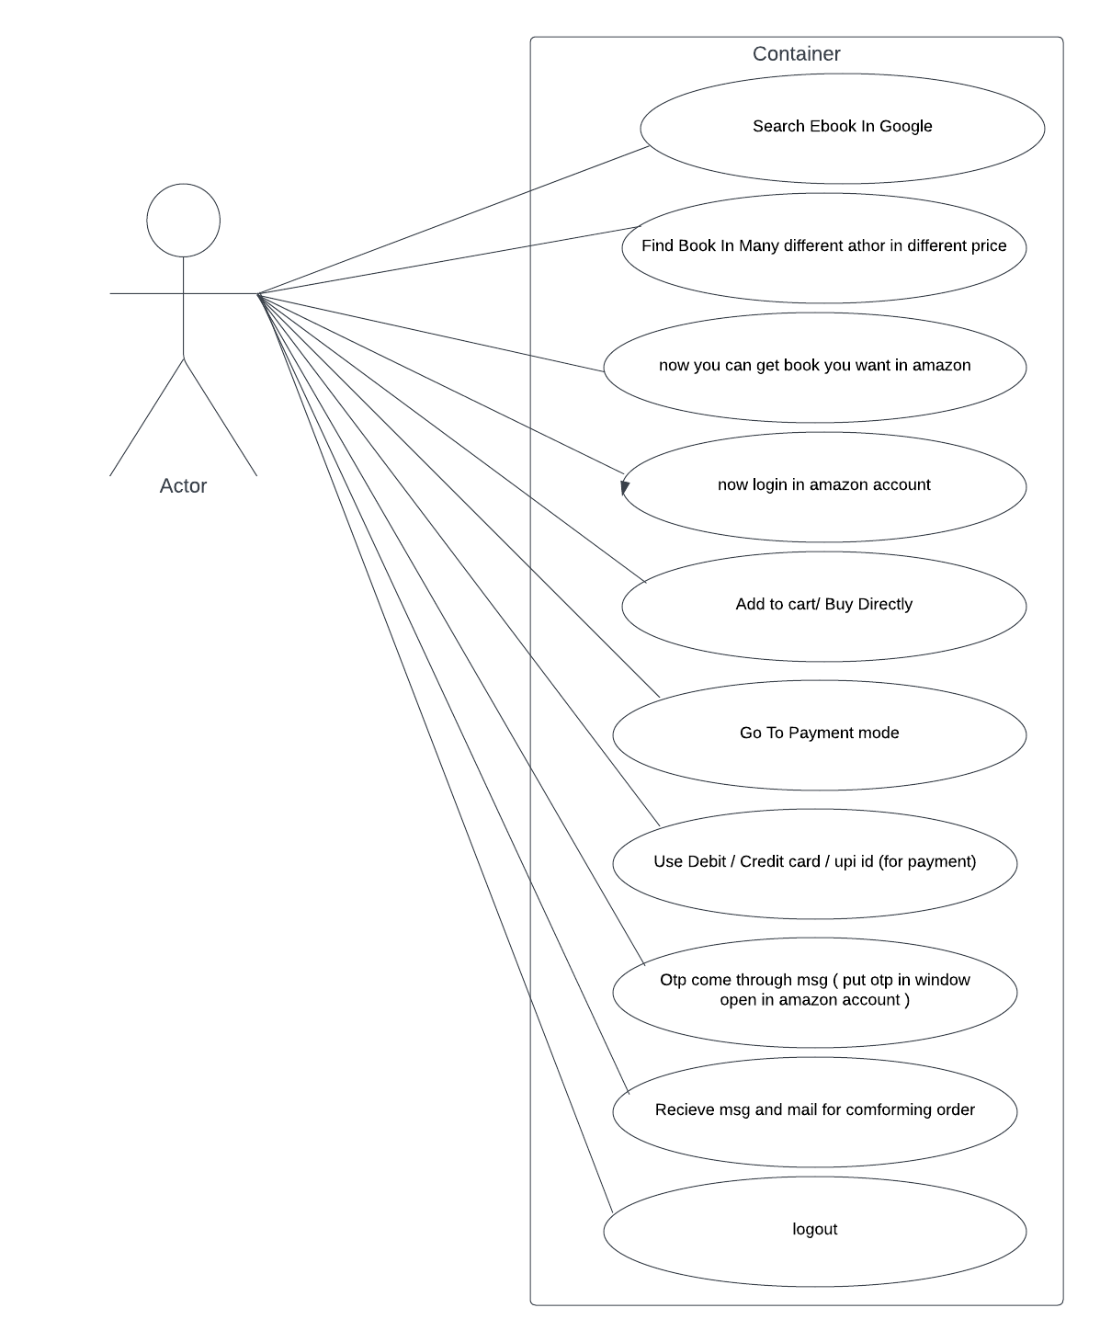

Q5. What is Flow chart? Create a flowchart to make addition of two numbers .

Ans. Flowcharts are nothing but the graphical representation of the data or the algorithm for a better understanding of the code visually. It displays step-by-step solutions to a problem, algorithm, or process. It is a pictorial way of representing steps that are preferred by most beginner-level programmers to understand algorithms of computer science, thus it contributes to troubleshooting the issues in the algorithm. A flowchart is a picture of boxes that indicates the process flow in a sequential manner. Since a flowchart is a pictorial representation of a process or algorithm, it’s easy to interpret and understand the process. To draw a flowchart, certain rules need to be followed which are followed by all professionals to draw a flowchart and is widely accepted all over the countries.

flowchart

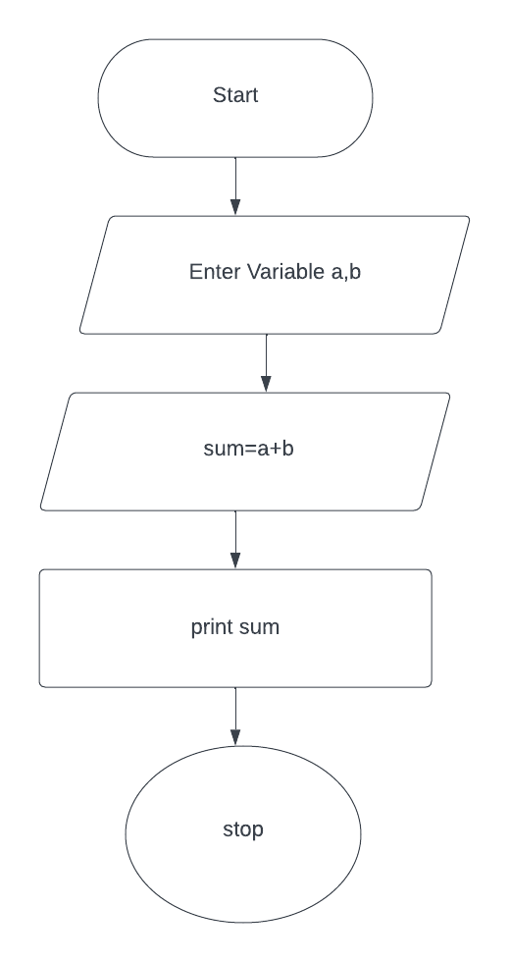

Q6. What is Use case Diagram? Create a use-case on bill payment on paytm.

Ans. A use case diagram is a way to summarize details of a system and the users within that system. It is generally shown as a graphic depiction of interactions among different elements in a system. Use case diagrams will specify the events in a system and how those events flow, however, use case diagram does not describe how those events are implemented. A [use case](https://www.techtarget.com/searchsoftwarequality/definition/use-case) is a methodology used in system analysis to identify, clarify, and organize system requirements. In this context, the term "system" refers to something being developed or operated, such as a mail-order product sales and service [Web site](https://www.techtarget.com/whatis/definition/Web-site). Use case diagrams are employed in [UML](https://www.techtarget.com/searchsoftwarequality/definition/Unified-Modeling-Language) (Unified Modeling Language), a standard notation for the modeling of real-world objects and systems. There are [a number of benefits](https://www.techtarget.com/searchsoftwarequality/news/1273406/The-pros-and-cons-of-use-case-diagrams) with having a use case diagram over similar diagrams such as flowcharts.

Create a use-case on bill payment on paytm.

